8

Two toy cars, green and yellow, are having a race.

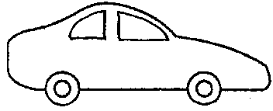
START
green
yellow
10 metres
8 metres

The green car travels 8 metres in 4 seconds.
The yellow car travels 10 metres in 6 seconds.

(a) Which car was faster?

Tick ONE box ()

❑ | The green car.
❑ | The yellow car.
❑ | Both had the same speed.

(b) Explain your answer: _______________________________________

______________________________________________________________

______________________________________________________________

______________________________________________________________

